Assignment 6.2
Assignment completed at 5:30 pm on April 22nd, 2026.
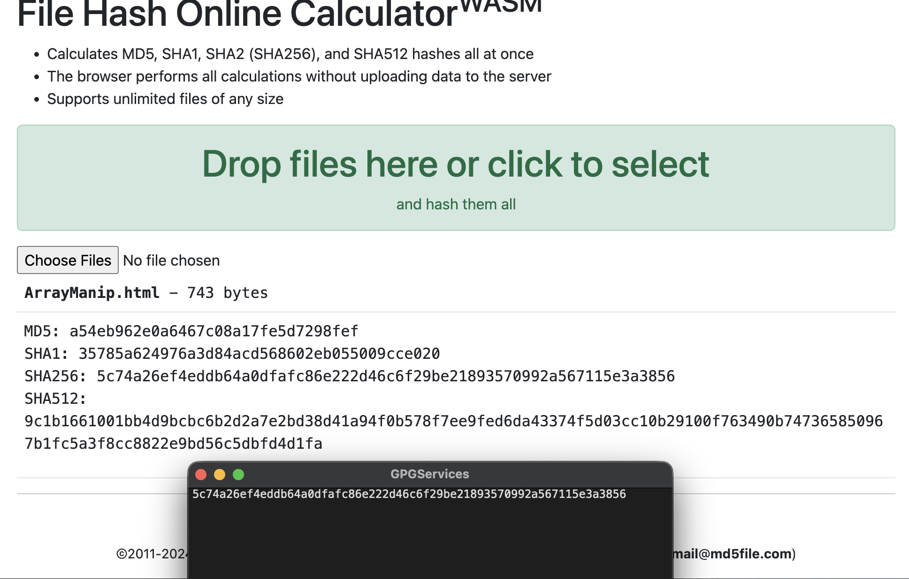

SHA256 from the website: 5c74a26ef4eddb64a0dfafc86e222d46c6f29be21893570992a567115e3a3856
From Professor’s Email:
5c74a26ef4eddb64a0dfafc86e222d46c6f29be21893570992a567115e3a3856

These values are identical. It appears to be the SHA-256 hash of the HTML document.

